Holidays Homework
Class- III
Subject- English
1)Make a model of Garden
2) Read one page of your text book daily and write down 10 new words
3) Revise new words .Q-Ans, back exercise of the chapter -Good Morning, The Magic Garden and Bird Talk
4) Wilte 15 pages of neat handwriting
5) Write 10 Rhyming words
6) Write 10 naming words from your textbook
7) Find out 10 opposite words from your textbook and write
8)Make a mask of your favourite bird or animal
- Note - Do all your Holiday homework in Extra Notebook

विषय- हिन्दी
- प्रतिदिन एक सुलेख लिखें |
- प्रतिदिन एक कहानी या कविता पढ़ें |
- 1 से 50 तक गिनती लिखने का अभ्यास करें |
- किसी भी एक जानवर का मुखौटा बनाकर उस पर 5 वाक्य लिखें व याद करें |
- 5 कीटों के नाम लिखें व चित्र चिपकाएँ |
- 5 ऐसे पक्षियों के नाम लिखें जिनमें आ, उ, ऊ, इ, ई की मात्रा आती है व उनके चित्र चिपकाओ |
- पाठ 1 व 2 याद करें |

DO ALL THE WORK IN SCRAP BOOK / THIN HOLIDAY HOMEWORK NOTEBOOK (NOT ON PAPERS)

Subject- EVS

1.Write the name of all states of India.
2.Write the name of three animals that live on
a) Land
b) Water
c) Tree
d) Forest
3. Write five lines about national flower of India.
4.Write five sources of water and five uses of water. Draw or paste the pictures of five sources of water.
5.Make poster on save water and write one slogan on it.
6.MDP Project- Paste five pictures of healthy food items and write about your favourite food item. Write five famous food of five different states.
7. Write your experience of summer vacation in ten lines.

Subject- Maths

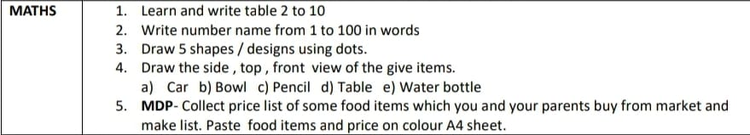

Subject- Computer
- Write five uses of computer on computer notebook.
- Write five advantages and five disadvantages of computer on computer notebook.
- Paste the pictures of any four parts of computer on computer notebook.

