Holidays Homewerk
Class- V
Subject- English
1. Make a habit of reading a story in English everyday.
2. Do atleast 25 page handwriting in separate English Notebook
3. Learn all the work done in English notebook
4. Write 5 lines on any of your favourite Vegetable and also draw its picture (Do in A4 sheet)
5. Make face mask of any animal or bird.
6. Make models of the following
a. Roll No.- 1 to 3 - Ladder
b. Roll No - 4 to 6 - Tree
c. Roll No - 7 to 9 - Bird (white)
d. Roll No - 10 to 12 - Basket Ball and Ring
e. Roll No - 13 to 15 - Ice cream
f. Roll No - 16 to 18 - Shake Bottles
g. Roll No- 19 and 20 - Write 10 opposite words on chart paper
h. Roll No - 21 and 22 - Write 10 singular plural on Chart paper
i. Roll No - 23 and 24 - Write Poem ‘Teamwork’ (8 lines on chart paper)
j. Roll No - 25 and 26 - Write Full forms (given on page - 27) on chart paper

Subject- EVS
1.Differentiate between healthy food and junk food. Draw or paste the pictures of healthy food and junk food.
2.Write five lines about state Andhra Pradesh.
3. How many super senses do human being have. Draw or the paste the pictures of super senses.
4.Locate all states on the map of India. Also write the capitals of different states of India.
5.Revision of chapter Super Senses and A snake charmer's story
6.MDP- What is shelter? Write the different types of shelter.What are the differences between Permanent shelter and Temporary shelter. Draw or paste the pictures of different shelters.
7. Write your experience of summer vacation in ten lines
Subject- Maths
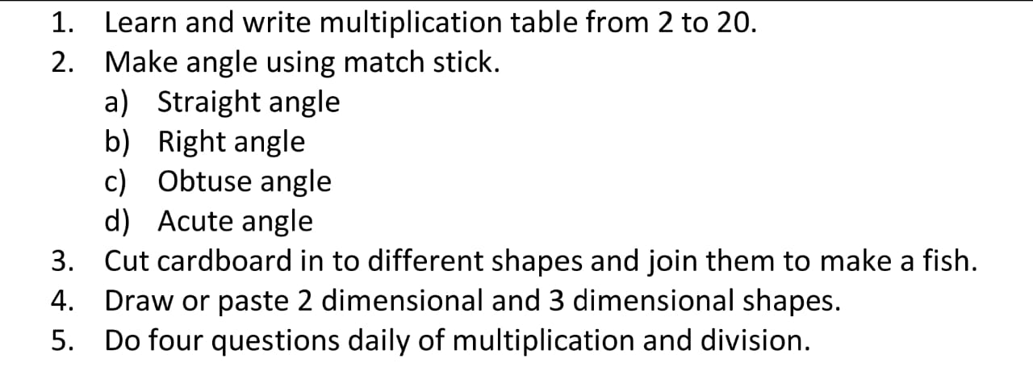

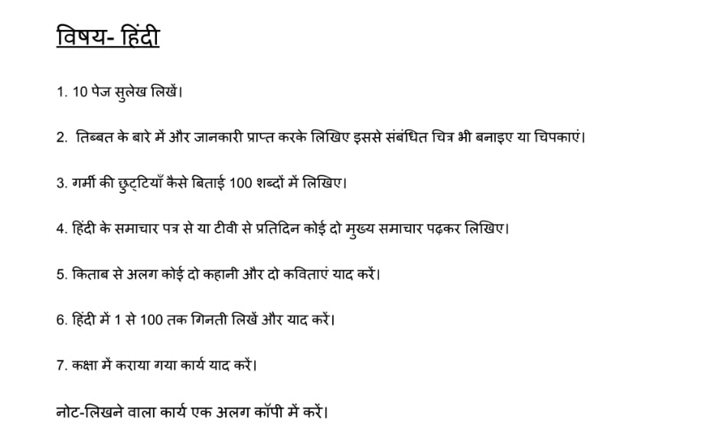
Subject- Computer
- Write advantages and disadvantages of internet on computer notebook.
- Write five uses of computer on computer notebook.
- Write Full forms on computer notebook.
- Paste the pictures of hardware and software devices on computer notebook.

