Holidays Homework 2023-24
Class - VIII
Subject- English
1. Write a letter to editor drawing attention towards noise pollution
2. Suppose you are going to meet Connie MacPherson to hand over her husband’s letter.write diary entry to express your feelings
3. Write a paragraph on:
1. Save water save life
2. Importance of reading
Any one
120-150words
4. Write three forms of verb(200 verbs)
विषय - हिंदी
प्रश्न 1 दिए गए दोनों विषयों पर 100 शब्दों में अनुच्छेद लिखिए।
1.इंटरनेट का बढ़ता प्रयोग
2. जीवन में खेलों का महत्त्व
प्रश्न 2 दिए गए विषयों पर संवाद लिखिए।
(क) वातावरण में बढ़ते प्रदूषण विषय पर दो मित्रों में संवाद लिखिए।
(ख) गुरु व शिष्य के बीच अनुशासन विषय पर संवाद लिखिए।
प्रश्न 3 प्राचार्य को पत्र लिखकर स्थानांतरण प्रमाणपत्र देने का अनुरोध कीजिये।
प्रश्न 4 संज्ञा की परिभाषा व उसके सभी प्रकार उदाहरण सहित लिखिए।
प्रश्न 5 विशेषण की परिभाषा व उसके सभी प्रकार उदाहरण सहित लिखिए।
प्रश्न 6 आप भविष्य में क्या बनना चाहते हैं? तथा आप अपना यह लक्ष्य कैसे प्राप्त करेंगे इस संबंध में विस्तार से लिखिए।
प्रश्न 7 अपनी पसंद की कोई एक कविता लिखिए व उससे संबंधित चित्र भी बनाइये।
प्रश्न 8 वसंत की पुस्तक से पाठ 1 लाख की चूड़ियां व पाठ2 बस की यात्रा के प्रश्नोत्तर याद कीजिये।
नोट - सारा कार्य A4 साइज़ के पेज में लिखकर फ़ाइल तैयार करें।
Subject- Maths
- What properties, the following expressions show?
(i) 23+45=45+23
(ii) 13×23=23×13
- What is the multiplicative identity of rational numbers?
- What is the additive identity of rational numbers?
- Solve the following linear equations:
(a) 4x + 5 = 9
(b) x + 3/2 = 2x
- In the given figure, ABCD is a parallelogram. Find x.
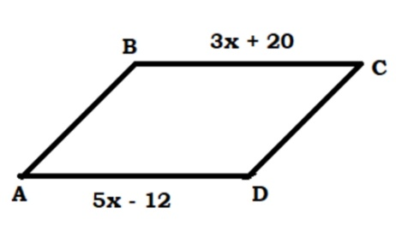
- Find the value of x
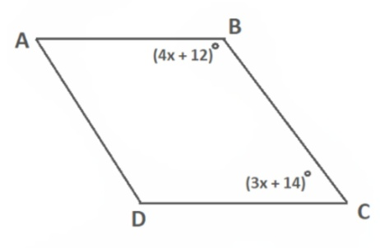
- Find the measure of an interior angle of a regular polygon of 9 sides
- In the given figure ABCD, find the value of x
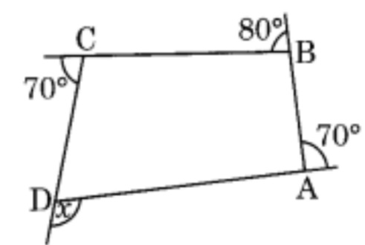
- Solve
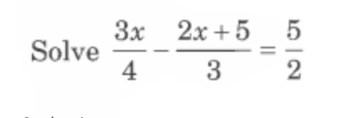
- The angles of a triangle are in the ratio 2 : 3 : 4. Find the angles of the triangle.
- In the given figure, ABCD is a parallelogram. Find x, y and z.
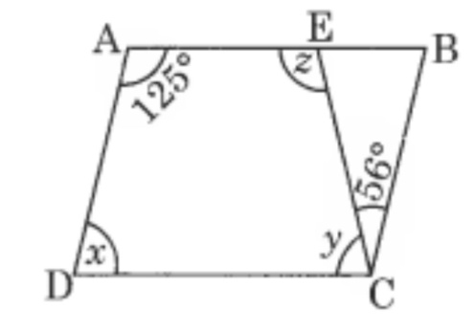
- Make a project on polygons.
- Find the values of x and y in the following parallelogram.
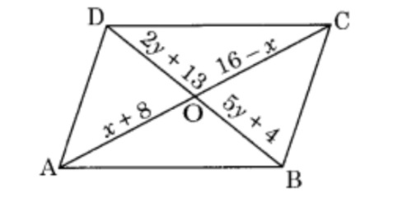
- A quadrilateral has three acute angles, each measure 80°. What is the measure of the fourth angle?
- The opposite angles of a parallelogram are (3x + 5)° and (61 – x)°. Find the measure of four angles.
- How many sides do a regular polygon have, if the measure of an exterior angle is given as 24° ?
- Select a false statement from those given below:
(a) A square is a rectangle that has equal adjacent sides
(b) A square is a rhombus whose one angle is a right angle
(c) The diagonals of a square bisect each other at right angles
(d) The diagonals of a square do not divide the whole square into four equal parts.
- The angles of a quadrilateral are in the ratio of 1 : 2 : 3 : 4. What is the measure of the four angles?

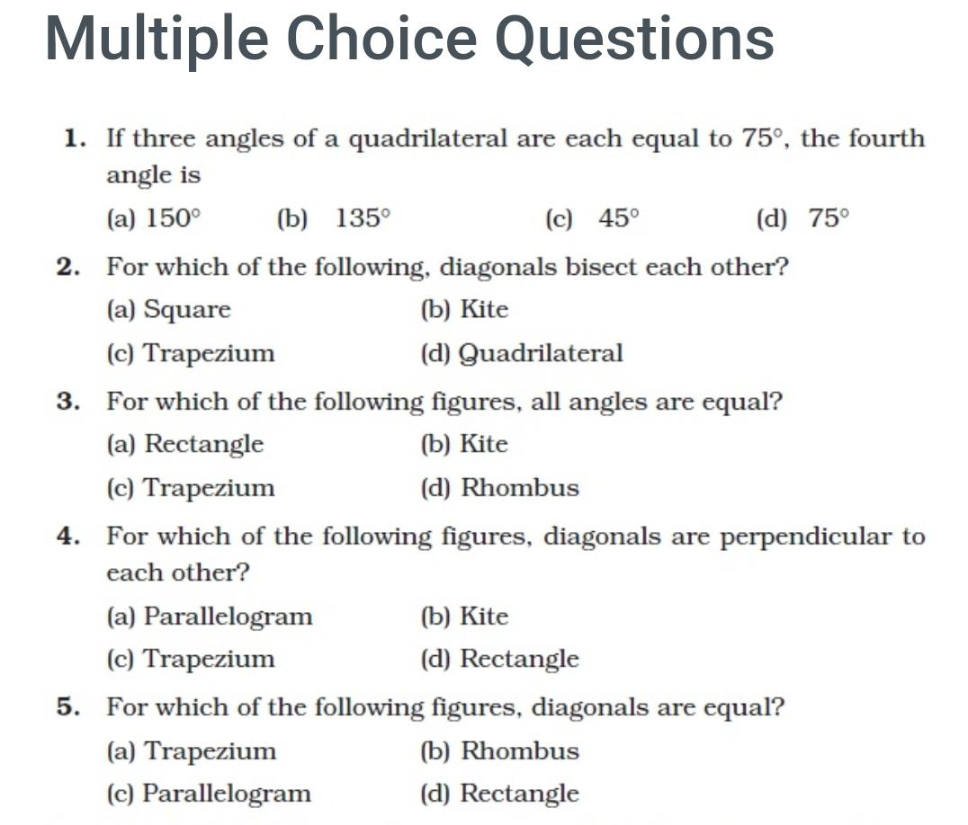
- Find
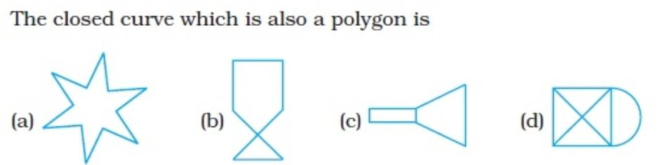

Subject-Science
- READ CHAPTER 1 AND 2 AND REVISE THEM.
- MAKE ATLEAST 10 EXTRA QUESTIONS FROM EACH CHAPTER AND WRITE IT IN THE NOTEBOOK.
- READ CHAPTER NO. 3
- MAKE A PROJECT FILE ON MICROORGANISMS.
Subject-Social Science
- WRITE AND LEARN THE ANSWER OF THE FOLLOWING QUESTIONS
1 what is Resource conservation?
2 what is sustainable development?
3 why are Resources distributed unequally over the earth?
4 why does a democratic country need a Constitution?
5 make a list of fundamental rights and duties
6 why did the British preserve official documents?
7. What attracted European trading companies to India?
8.Explain the system of subsidiary alliance.
9 In what ways was the administration of the company different from that of Indian rulers
10 what was the problem with the periodisation of Indian history that James mill offers?
ACTIVITY BASED CREATIVE WORK
1Start writing diary. Before sleeping write about what you did the whole day.
2.Project work 2- Make art integrated project on anyone of the following topics (pages 10to 15 pages)
First introduction of the odisha State and map
- Great personalities of the odisha state.
- Famous historical place, monuments,forts and caves
- Culture of odisha state food, costume, language, religious centre and literature
3. Flash Cards- Make Flash cards on any major crop highlighting theirgeographical conditions.
4. Make a project on any non-conventional sources of energy like -Solar, Wind energy, Nuclear power, Geo thermal energy, Tidal energy and Biogas Project should contain following points –▪ Index, Acknowledgement, Introduction, Recent developments, Innovative techniques to harness energy, Distribution in the world, Conclusion, Sources of information etc.
OPTIONAL
5. Design a preamble for your school abiding to all the rights and duties of all the students in school. You can also take hint from preamble of 'Constitution of India'.
6. Collect and organise all the information about your favourite freedomfighter in form of biography. Also discuss the traits of that person that you would like to adapt in your life.
7. Interview women of different generations e.g. your grandmother, mother, sister, friend and discuss the hardships women have been facing from decades. List some revolts lead by the women in history.
8. Plant a tree on occasion of world environment day 5th June and take a photo
विषयः - संस्कृतम्
१. प्रथम-पाठस्य स्मरणम् (कक्षा-परीक्षा)
२. द्वितीय-पाठस्य केवलं पठनम्
३. एकस्य संस्कृत-गीतस्य सस्वर-गायनम् /त्रयाणां श्लोकानां सस्वर-गायनम्
४. विभक्तिं योजयित्वा वाक्य-रचना
प्रथमा विभक्तिः - 10 वाक्यानि (लेखनम्)
द्वितीया विभक्तिः - 10 वाक्यानि (लेखनम्)
तृतीया विभक्तिः - 10 वाक्यानि (लेखनम्)
चतुर्थी विभक्तिः - 10 वाक्यानि (लेखनम्)
पञ्चमी विभक्तिः - 10 वाक्यानि (लेखनम्)
षष्ठी विभक्तिः - 10 वाक्यानि (लेखनम्)
सप्तमी विभक्तिः - 10 वाक्यानि (लेखनम्)
५. १ त: १०० पर्यन्तं सङ्ख्या स्मरणम्
६. नवसृजनात्मक-परियोजना-कार्यम्
उपविषय: - प्राचीने भारते आयुर्वेद: विज्ञानं प्रौद्योगिकी च
(प्राचीन भारत में आयुर्वेद विज्ञान और प्रौद्योगिकी)
परियोजना कार्य करते समय वर्तमान से जोड़कर उस विषय को पढ़ते हुए अपना विचार भी प्रस्तुत करें कि भविष्य में क्या किया जा सकता है।

Subject- Computer
- Answer the following questions on computer notebook:
- Define MS-Excel?
- Write five uses of MS-Excel?
- Write the difference between Windows 7 &Windows 10.
- Draw MS-Excel worksheet on A4 paper.

